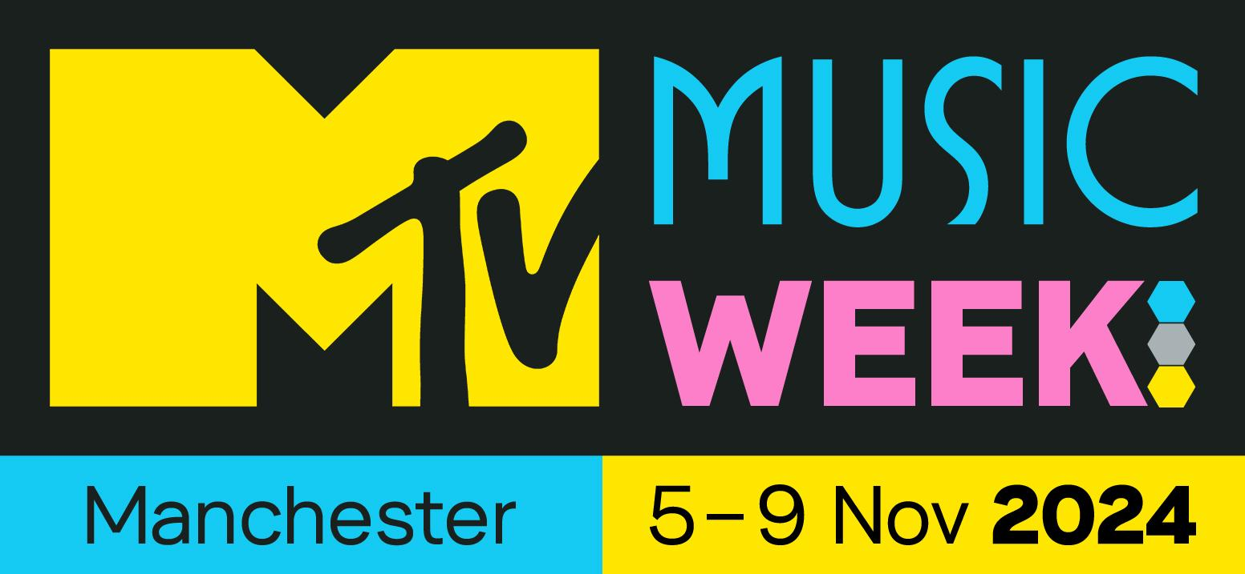

MTV PRESENTS AN UNMISSABLE WEEK-LONG CITY TAKEOVER TO CELEBRATE THE MTV EMAS COMING TO MANCHESTER

MTV Music Week (5 – 9 November) Will Showcase The Best Of Manchester’s Emerging Artists And Favourite Venues

GET TICKETS HERE
DOWNLOAD ASSETS HERE
SOCIAL TAGS: #MTVEMA @MTVEMA

MANCHESTER (26 September 2024) – MTV has today announced MTV Music Week will take place across some of Manchester’s most loved venues between 5th – 9th November, ahead of the 2024 MTV EMAs, taking place at Co-op Live on 10th November. Featuring homegrown artists, unforgettable performances and industry workshops, MTV Music Week promises fans a dive into Manchester’s diverse music scenes.

Throughout the week, MTV will take over the city as it hosts a range of live music events each day at local venues, featuring Manchester’s hottest breakthrough artists. MTV’s iconic franchises will take centre stage, including MTV Push Live, Club MTV and YO! MTV Raps, showcasing the wide offering of the brand and leaving a legacy of MTV memories in Manchester.

“Music is truly woven into Manchester’s DNA, and MTV Music Week’s line-up is testament to the talented community within the city’s many diverse and thriving music scenes. With a wide selection of events that pair our portfolio of music brands with the city’s breadth of venues and artists, our aim is to celebrate Manchester’s rich music culture and ensure it is enjoyed and experienced by all.” Said Russell Samuel, SVP Creative and Integrated Marketing, Paramount International Markets.

Councillor Bev Craig, Leader of Manchester City Council, added: "Our music scene in Manchester is the stuff of legend and we're known the world over for our brilliant musicians and iconic venues. MTV Music Week will be a great showcase for our city and the stage is set for an incredible Manchester music takeover. A boost for the industry, our economy, and fantastic opportunities for some of our best homegrown artists as well as unforgettable performances for audiences to enjoy. We’re excited, can’t wait!"

See the full line-up for MTV Music Week below.

Tuesday 5 November

MTV Gonzo on Tour | Rebellion | 7.30PM – 10.30PM
MTV Music Week kicks off at alternative music venue Rebellion with the epic indie and alternative music show MTV Gonzo on Tour. Bringing together some of UK’s best emerging indie rock bands and artists under one roof, the night will feature a line-up of exciting breakthrough artists including post punk trailblazers Dead Pony.

Wednesday 6 November

MTV Push Live | Soup | 7PM – 10.30PM
Ready to introduce fans to the hottest new breakthrough artists across Manchester’s thriving music scene, Wednesday will see MTV Push Live head to the award-winning live music venue, Soup. Featuring a co-curated line-up from Manchester music initiative Beyond the Music, the night will include unmissable performances from LARKINS, Phoebe Hall and more. The event sees the continuation of MTV Push and Beyond the Music’s partnership, which is set to kick-off with a team-up at Beyond the Music’s annual festival in October. At the festival, attendees will enjoy an MTV Push Live stage, plus MTV-curated panels.

MTV x Ramona Radio Rave | Ramona | 7PM – 12AM
On the same night, Ramona will welcome some of Manchester’s hottest emerging dance music talents, with sets from Chunky, Ms Dee and Sno as part of a Ramona Radio MTV Takeover.

Wednesday 6 – Friday 8 November

MTV EMA: 30 Years | Aviva Studios, home of Factory International | 10AM – 8PM
For music fans looking to reminisce and take a trip into the MTV EMAs’ legendary history, the MTV EMA: 30 Years exhibition will run at Manchester’s arts and culture venue Aviva Studios, home of Factory International. Featuring images from all past editions of the MTV EMAs, curated from Getty Images' archive, the exhibition celebrates the artists, performances and pop culture moments that have created a cultural legacy for generations of fans across the globe.

Thursday 7 November

MTV Push Live | Band On The Wall | 7PM – 11PM
MTV Music Week continues with MTV Push Live at Band On The Wall, hosted by the electrifying Manchester DJ duo Shimrise. Delivering an evening featuring the city’s most exciting breakthrough talent, fans can expect a series of unique performances from alt-pop musician Nxdia, singer-songwriter Nina Cobham and R&B Soul artist Rumbi Tauro.

MTV Presents: Piri & Tommy | New Century | 7PM - 11PM
MTV Presents: Piri & Tommy arrives at New Century for a night of uplifting drum and bass, inspired by the UK’s student basement club culture. The pair, who first formed the band during COVID, were last year included in MTV Push’s Top 10 Artists list and made the longlist on BBC Radio 1’s Sound of 2023. Piri & Tommy’s latest track ‘99%’ marks the group’s first release in a year.

Piri & Tommy said: “We are so grateful to Manchester for literally birthing our career and so much of our music. This city is truly where it all began for us as artists and musicians. The music scene is so welcoming, and the city is so full of creative energy, we couldn’t have wished for a better starting point. it feels so good to be coming back to Manchester now as the artists we have grown to be, and we’re so thankful to MTV for having us and for always supporting us and our music!”

Friday 8 November

Yo! MTV Raps: NQ Rated | Freight Island | 7PM - 11PM
The show that first gave rap and hip hop a global stage, YO! MTV Raps comes to Freight Island for an exclusive YO! MTV Raps x NQ showcase. A must-see live music experience, the Manchester label behind the acclaimed Northern rap scene has partnered with MTV to host a line-up including headliner Nemzzz, 163Margs and more.

NQ said of the partnership: “To see the MTV EMAs being hosted in Manchester this year is great for the city, especially as music has always played such a big part of the city’s identity. As a leading northern independent entertainment company, the partnership with the YO! MTV Raps brand allows us to curate a diverse line up of the hottest talent coming out of the North-West and wider UK rap scene as well as provide opportunities for young people in the community to get involved throughout EMA week in the city”.

Saturday 9 November

MTV x Homobloc Brunch Royale | DieCast | 12 PM – 3 PM
Those looking for the perfect Homobloc pre-party need look no further, as the storied LGBTQ+ event teams up with MTV for a mega brunch party at DieCast. Expect a spectacular show featuring special guests and led by some of Manchester’s most celebrated Queens Banksie & Lil, and a battle on the catwalk from Ghetto Fabulous presenting Black Peppa, Coco Canell, Shanika Sunrise & Verry Cherry, soundtracked by Gaydio’s Jackie P & Gina Breeze.

MTV x Homobloc | The Roof Terrace at Depot Mayfield | 4PM-11PM
Continuing the Homobloc celebrations, MTV is also hosting The Rooftop at Manchester nightlife institution Depot Mayfield featuring stage collaborations with local LGBTQ+ parties Homoelectric and Make Me Feel. Artists appearing across the roof terrace stages include Nicky Siano (Studio 54), Prosumer, ShyOne, Grove b2b Tash LC, Ruby Savage and local favourites Meme Gold and Kath McDermott, plus a fabulous collection of queens.

Club MTV Presents: salute | Hidden | 10PM – 4AM
A pivotal city in the dance music revolution, Manchester’s cutting-edge dance scene is renowned across the globe, and what better way to close the week-long city takeover than with a night that celebrates one of the city’s most exciting emerging DJs, plus mega headliner salute. Named ‘Best Club’ in DJ Mag’s Best of British Awards in 2023, Hidden has become a staple in the Manchester clubbing scene and the premier destination for electronic fans.
For more information and tickets for MTV Music Week, please visit this link.
Alongside MTV Music Week and the 2024 MTV EMAs, Paramount’s Creators House is also headed to Manchester. Part of Paramount’s Content for Change event series, this company-wide, social impact-led initiative will take place across the 7th, 8th and 9th November with a packed slate of programming and networking opportunities aimed at Manchester’s creative community. More information on Creators House will follow.
Fans can stay up-to-date with all things MTV EMAs by heading to https://www.mtvema.com/ following the show on Instagram, Snapchat, X, TikTok and Facebook and follow the social conversation using #MTVEMA.
- ENDS -
Press Contacts

For more information on the events, ticket pricing, images and interviews, please contact:

Carousel PR
MTVEMAS@carouselpr.com
0161 302 0206

MTV PR
Julia.besley@paramount.com
Harriet.scott@paramount.com

About the 2024 MTV EMAS
The 2024 MTV EMAs will broadcast LIVE across the globe on Sunday 10th November from Manchester, UK. One of the biggest global music events that celebrates the world’s most iconic artists, the MTV EMAs bring fans a unique, multi-platform experience across MTV’s global network in nearly 150 countries. Follow @MTVEMA on Facebook, X, Snapchat, Instagram and TikTok, and join the conversation with #MTVEMA. Bruce Gillmer and Richard Godfrey are Executive Producers for the 2024 MTV EMAs. Debbie Phillips and Chloe Mason are Producers.

About MTV Music Week
Over its several editions, MTV Music Week has set the stage for the MTV EMAs with a week of music celebrations in each EMA Host City. Since 2011, the fan event series has celebrated the music scenes of several cities across Europe, including Frankfurt, Amsterdam, Glasgow, Milan, Rotterdam, Bilbao, Budapest and Düsseldorf, combining each location’s breadth of venues, genres and artists with the global power of MTV’s music brands in an MTV-curated city takeover.

About Content for Change
Paramount’s Content for Change is a global company-wide, cross-brand initiative that seeks to harness the power of content to counteract racism, bias, stereotypes, and all forms of hate. Informed and inspired by BET’s groundbreaking campaign, Content for Change applies scientific research, rigor, and data to transform the entire creative ecosystem across three pillars – the content the company produces, the creative supply chain that powers it, and the culture that underpins everything Paramount does. For more information, go to www.contentforchange.paramount.com

***

Notes to Editors

For press accreditation across the 2024 MTV EMAs, MTV Music Week and Creators House, please contact Carousel PR (contact information above).

Previous editions of the MTV EMAs have taken place in the following cities: Berlin, Paris, London, Rotterdam, Milan, Dublin, Stockholm, Frankfurt, Barcelona, Edinburgh, Rome, Lisbon, Copenhagen, Munich, Liverpool, Madrid, Belfast, Amsterdam, Glasgow, Bilbao, Seville, Budapest, Dusseldorf.

