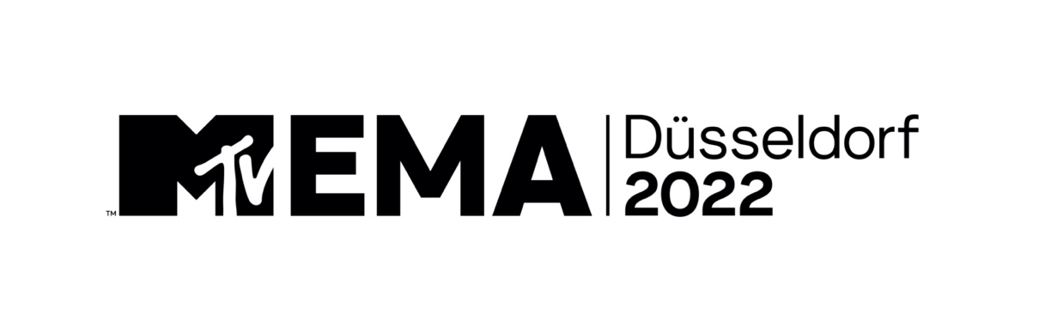
MTV ANNOUNCES DÜSSELDORF AS HOST CITY FOR
“MTV EMAS” 2022

Global Music Celebration To Air Live Around the World on November 13th

IMAGES
NEW YORK / DÜSSELDORF – May 24, 2022 – MTV today announced the “MTV EMAs” 2022 will take place in Düsseldorf at PSD Bank Dome, marking the annual global music celebration’s sixth time in Germany. The ‘EMAs’ will broadcast live on MTV in more than 170 countries on November 13th and feature show-stopping performances and appearances from the world’s biggest stars.

“There is no other event like the ‘MTV EMAs’ which connects audiences in every corner of the world to their favorite artists,” said Raffaele Annecchino, President & CEO, International Networks, Studios, & Streaming, Paramount. “We can’t wait to head back to Germany to bring today’s biggest stars, young changemakers and superfans together for the ultimate global music celebration.”

“As we celebrate the 25th anniversary of MTV Germany, we’re excited to return to the incredible country where we hosted our first ‘EMAs’ back in 1994 in front of Berlin’s iconic Brandenburg Gate,” said Bruce Gillmer, President of Music, Music Talent, Programming and Events, Paramount, and Chief Content Officer, Music, Paramount+. “Düsseldorf is a vibrant, multicultural city and the perfect setting for an epic night celebrating today’s top artists and the incredible power of music to cross borders and unite us.”

Host, nominees, performers, and presenters to be announced later.

Previous ‘EMAs’ held in Germany were Berlin (1994 & 2009), Frankfurt (2001 & 2012), and Munich (2007).

The “2021 MTV EMAs” were held live from the Papp László Budapest Sportaréna in Hungary. Hosted by rap superstar Saweetie, the epic event featured electrifying performances from Ed Sheeran, Maluma, Imagine Dragons, Kim Petras, Måneskin and honored some of the world’s biggest artists while also celebrating music, love, and equality. For the first time, the “MTV EMA Generation Change Award” recipients were recognized during the main show and MTV honored five young changemakers furthering equality and love while fighting against anti-LGBTQ+ policies.

ABOUT THE “MTV EMAs”:
One of the biggest global music awards shows of the year that celebrates the hottest artists from around the world, the MTV EMAs bring music fans a unique, multi-platform experience across MTV’s global network in 170+ countries. Follow @MTVEMA on Facebook, Twitter, TikTok and Instagram, and join the conversation with #MTVEMA. Bruce Gillmer and Richard Godfrey are Executive Producers. Debbie Phillips and Chloe Mason are producers.
###

PRESS CONTACTS:
Heather Brown / MTV International / Heather.Brown@paramount.com
Christina Ringstrom / MTV International / Christina.Ringstrom@paramount.com
Claas Paletta / MTV Germany / Claas.Paletta@vimn.com

